
Quality by Design approach in the development of hydrophilic interaction liquid chromatographic method for the analysis of iohexol and its impurities

The objective of this research paper is to develop a hydrophilic interaction liquid chromatographic method for the analysis of iohexol, its endo-isomer and three impurities following Quality by Design approach. Design of experiments (DoE) methodology is implemented for the creation of the relationship between critical process parameters and critical quality attributes.
The factors (independent variables) examined are: X₁ = acetonitrile content in the mobile phase (%), X₂ = pH of the water phase and X₃ = ammonium acetate concentration in the water phase (mmol/L). All the factors are continuous. The responses (dependent variables) examined are: k₁ = retention time of related compound C, k₂ = retention time of related compound B, k₃ = retention time of related compound A, k₄ = retention time of exo-iohexol and k₅ = retention time of endo-iohexol. The applied DoE method is Box Behnken design.
Isalos version used: 2.0.6
Scientific article: https://www.sciencedirect.com/science/article/abs/pii/S073170851500151X

Step 1: Box Behnken Design
In the first tab named “Action” define the factors in the column headers and fill each column with the low and high levels of the corresponding factors. This tab can be renamed “Box Behnken”. Afterwards, apply the Box Behnken method: DOE $→$ Response Surface $→$ Box Behnken

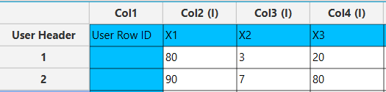

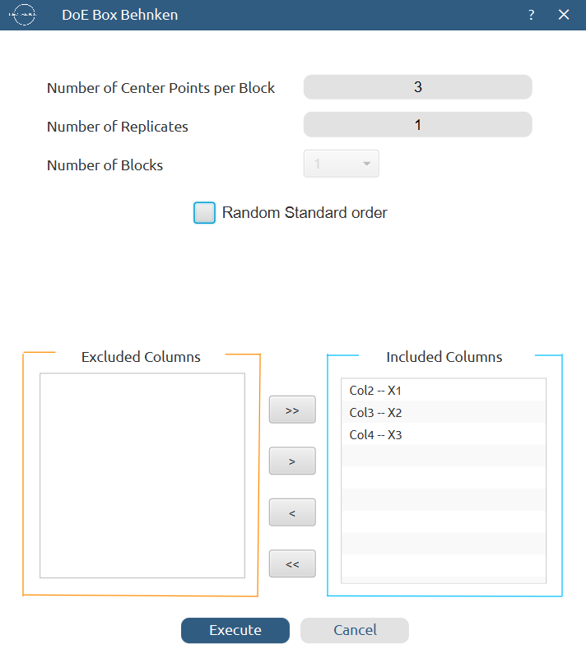

Results (right spreadsheet):
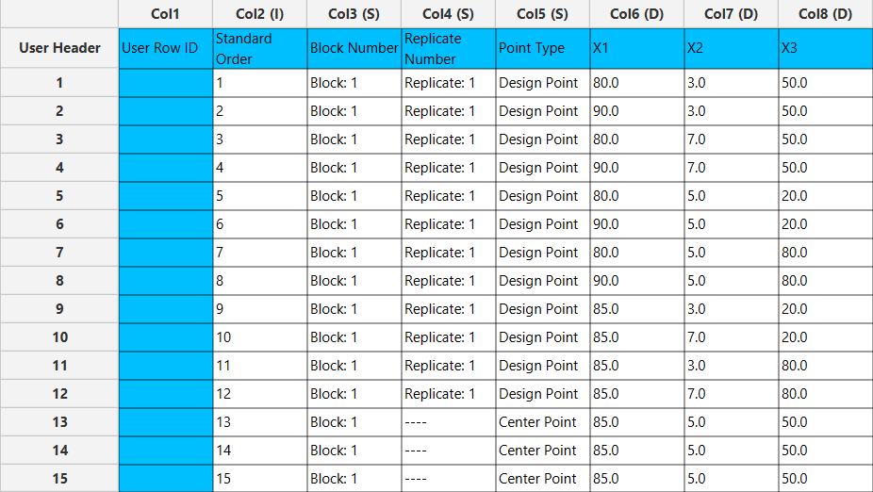

Step 2: Definition of response variables
Create a new tab named “Responses” and define the responses in the column headers. Fill each column with the values of the corresponding responses that were observed and make sure the values follow the order of the experiments as given by the Box Behnken method. Then, select all columns to be transferred to the right spreadsheet: Data Transformation $→$ Data Manipulation $→$ Select Column(s)

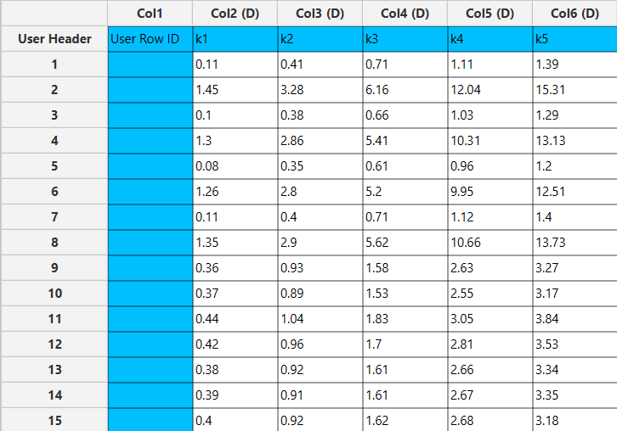

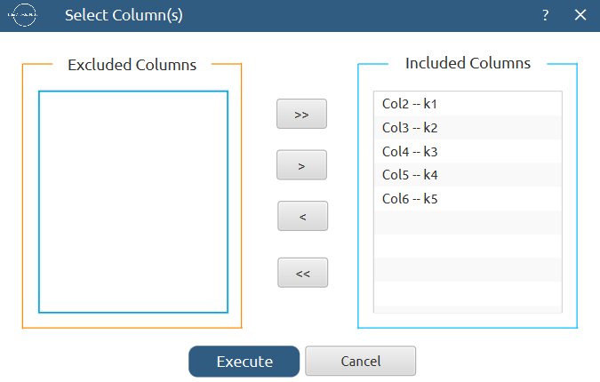

Step 3: Data isolation
Create a new tab named “Data” and import the results from the “Box Behnken” and “Responses” spreadsheets by right clicking on the left spreadsheet. Then, select only the factors and responses columns to be transferred to the right spreadsheet: Data Transformation $→$ Data Manipulation $→$ Select Column(s)
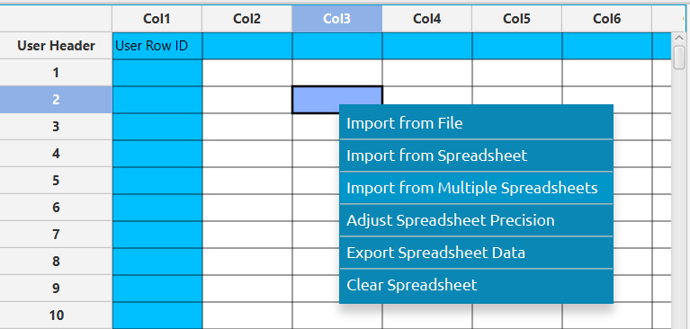

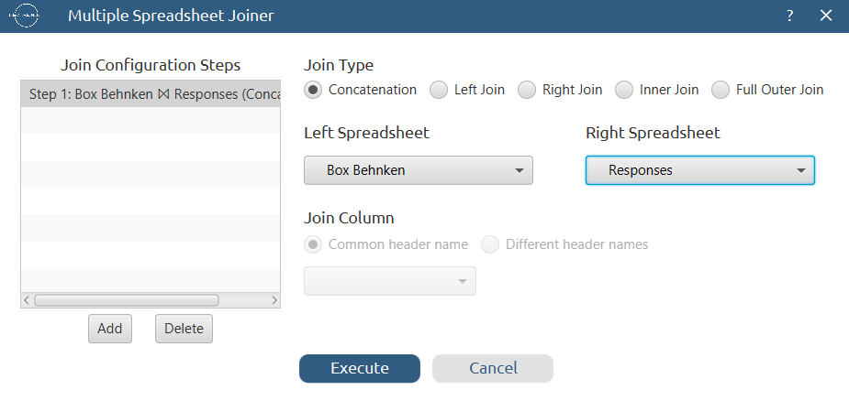

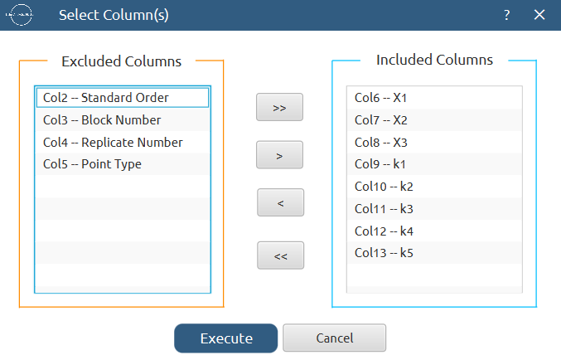
Results:
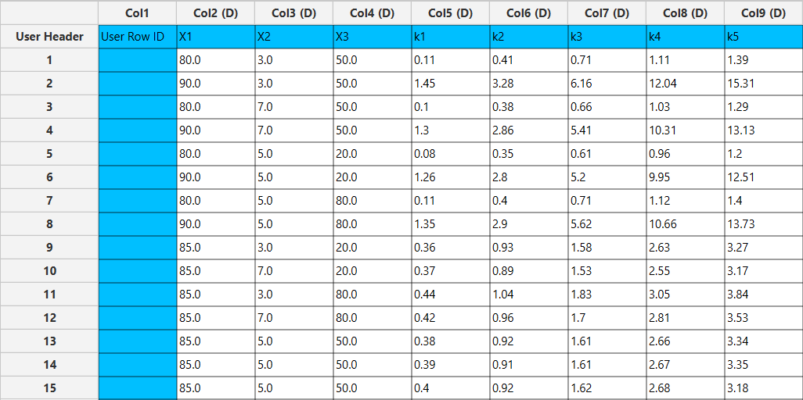

Step 4: Normalization
Create a new tab named “Normalized data” and import the results from the “Data” spreadsheet. Afterwards, normalize the factor columns to take values in the range [-1, 1]: Data Transformation $→$ Normalizers $→$ Min-Max


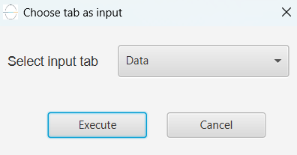

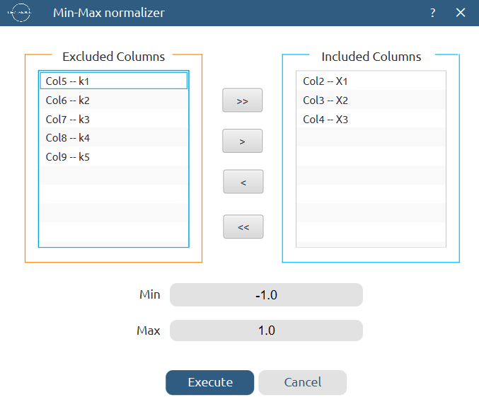

Results:
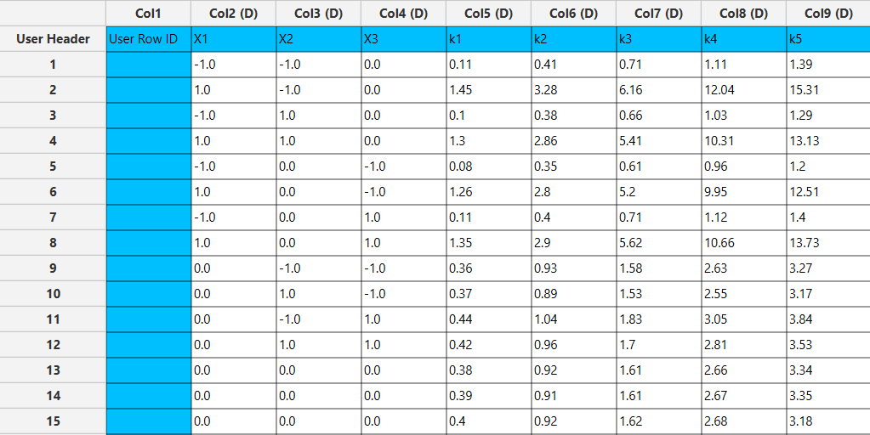

Step 5: Regression
The goal here is to produce a regression equation that includes main effects, two-factor interactions and quadratic effects for k₁:
$$k=b_{0}+b_{1}X_{1}+b_{2}X_{2}+b_{3}X_{3}+b_{12}X_{1}X_{2}+b_{13}X_{1}X_{3}+b_{23}X_{2}X_{3}+b_{11}{X_{1}}^{2}+b_{22}{X_{2}}^{2}+b_{33}{X_{3}}^{2}$$

Create a new tab named “Regression – k1” and import the results from the spreadsheet “Normalized data”. Afterwards, fit a generalized linear model to the data: Analytics $→$ Regression $→$ Statistical fitting $→$ Generalized Linear Models

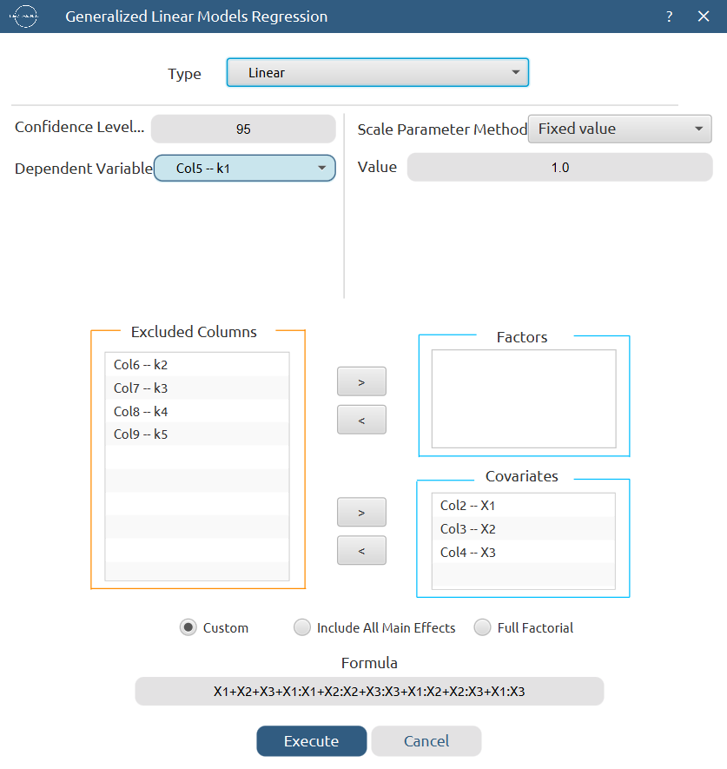

Results:

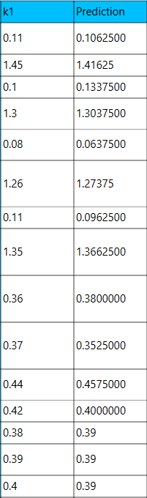
#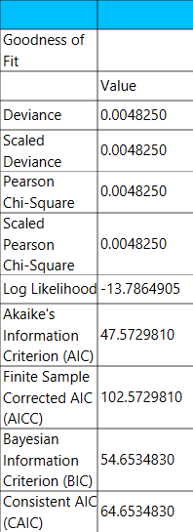

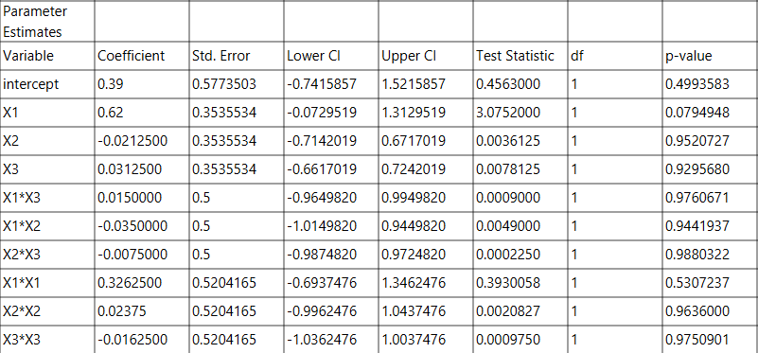

Repeat this step for the rest of the response variables. Results, k₂:

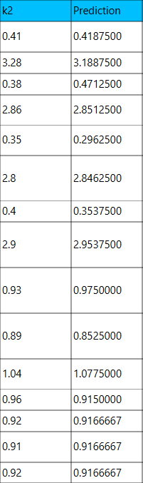
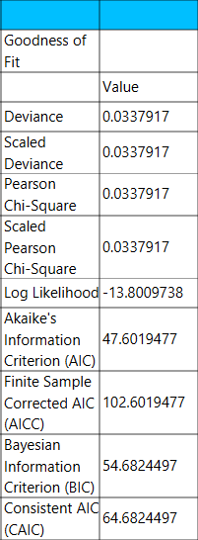

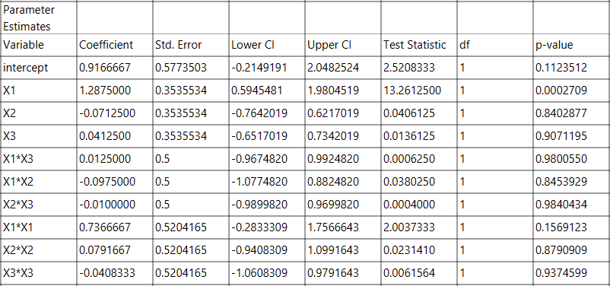

Results, k₃:

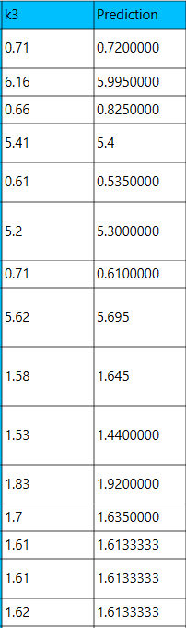
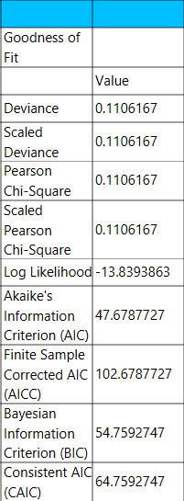

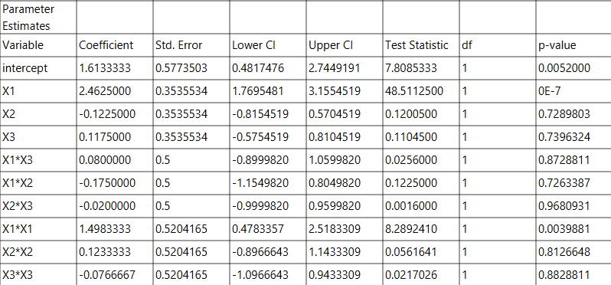

Results, k₄:

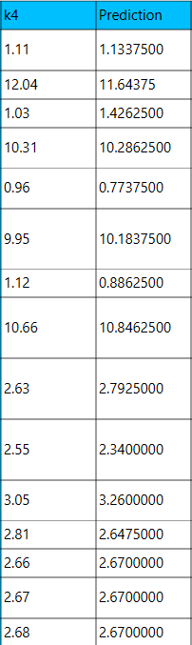
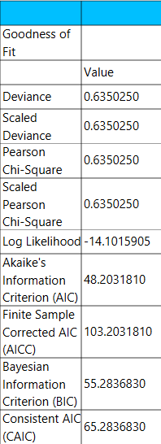

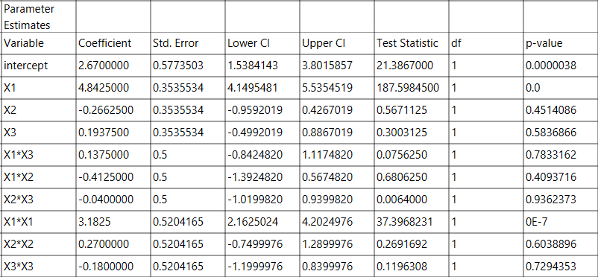

Results, k₅:

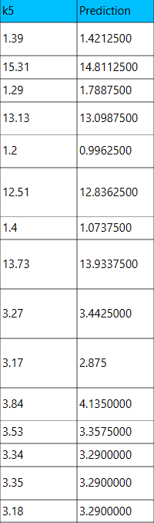
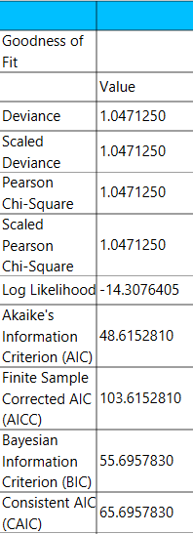

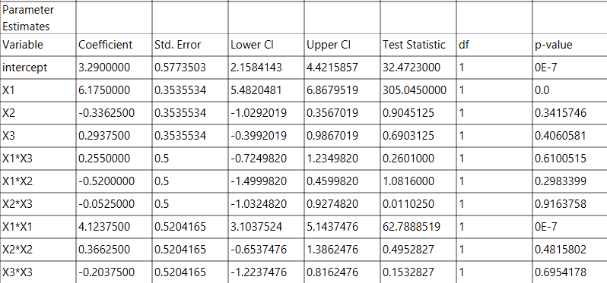

Step 6: Regression Metrics
Create a tab named “Metrics – k1” and import the results from the spreadsheet “Regression – k1”. Then, produce the regression metrics for the k₁ regression equation: Statistics $→$ Model Metrics $→$ Regression Metrics

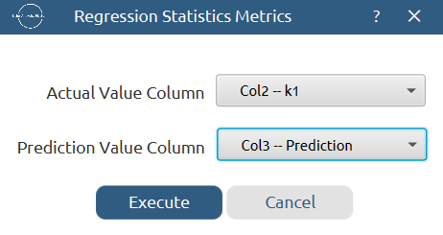

Results:
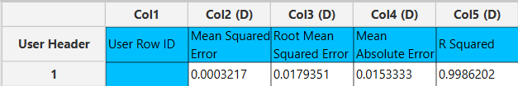

Repeat this step for the rest of the response variables. Results, k₂:
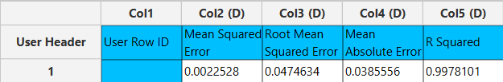

Results, k₃:
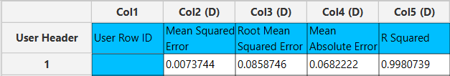

Results, k₄:
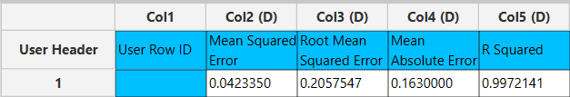

Results, k₅:
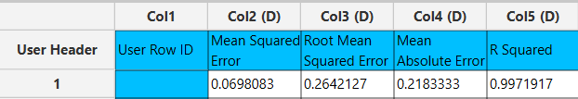

Step 7: Analysis of Covariance
Create a new tab named “ANCOVA – k1” and import the results from the spreadsheet “Normalized data”. Afterwards perform analysis of covariance for k₁: Statistics $→$ Analysis of (Co)Variance $→$ ANCOVA
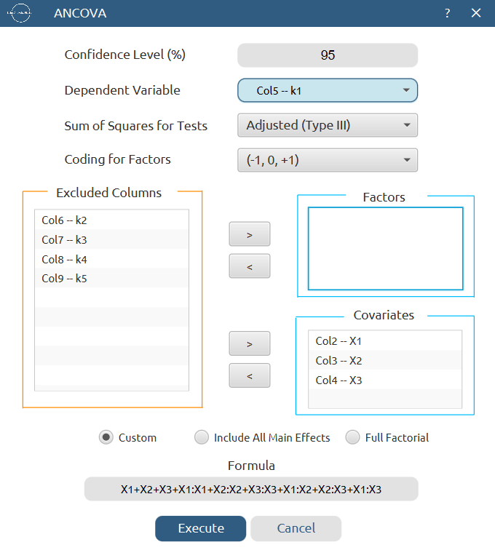

Results:
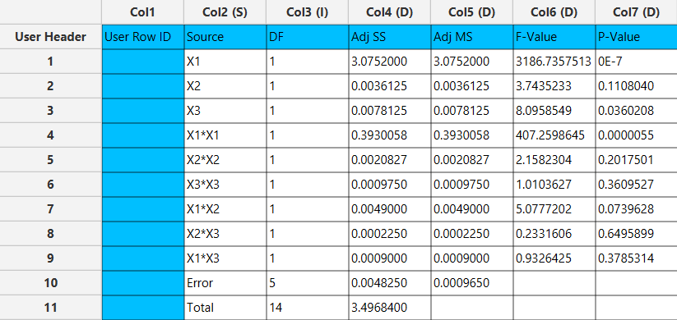

Repeat this step for the rest of the response variables. Results, k₂:
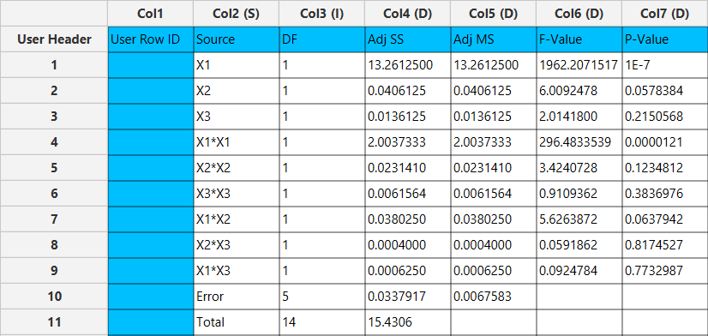

Results, k₃:
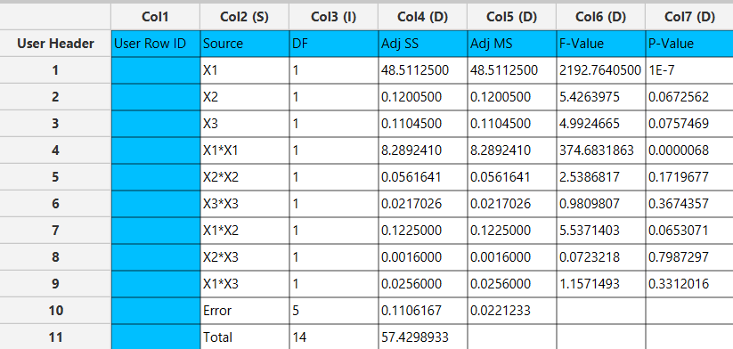

Results, k₄:
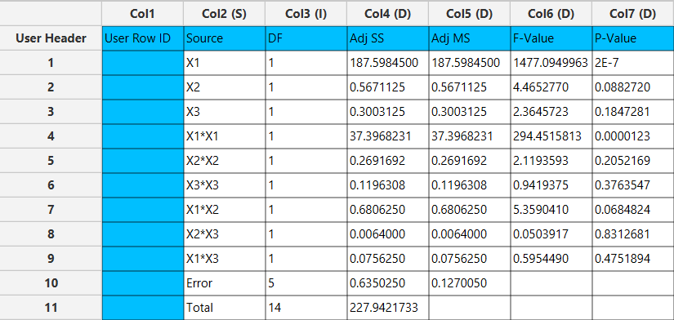

Results, k₅:
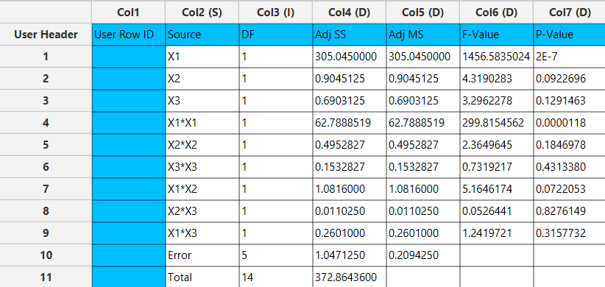

Final Isalos Workflow
The final workflow is presented below (doesn’t fully fit):
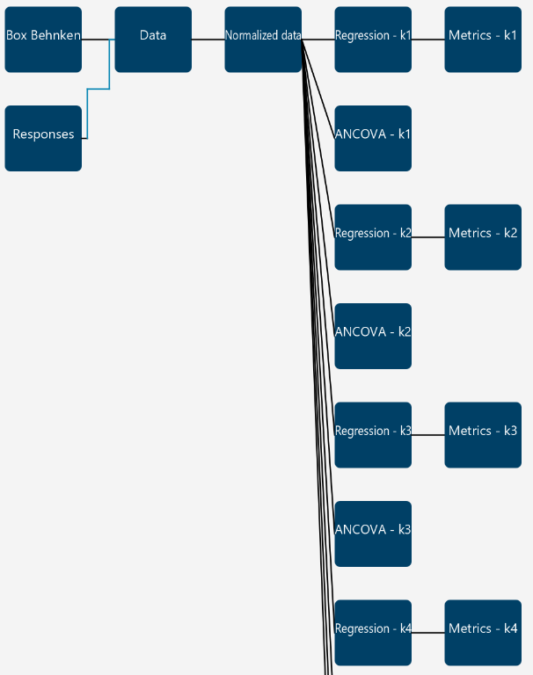

References
(1) Jovanović, M.; Rakić, T.; Tumpa, A.; Jančić Stojanović, B. Quality by Design Approach in the Development of Hydrophilic Interaction Liquid Chromatographic Method for the Analysis of Iohexol and Its Impurities. Journal of Pharmaceutical and Biomedical Analysis 2015, 110, 42–48. https://doi.org/10.1016/j.jpba.2015.02.046.

